**HOME NETWORK TOPOLOGY**

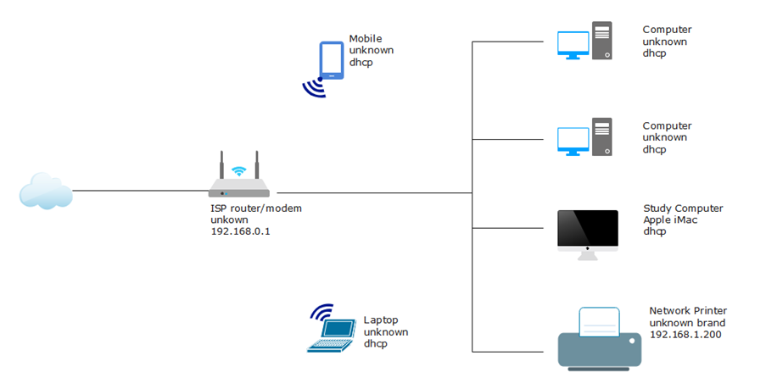

**Explanation:** A **Home Network Topology** is a **logical and/or physical layout** that shows how different devices—like laptops, smartphones, smart TVs, desktops, and printers—are **connected** to each other and to the internet within a home environment.

It helps ensure **efficient communication**, **secure data sharing**, and **internet access** across multiple devices.

**A well-designed home network topology provides:**

* ✅ **Internet Access** for all devices through a single broadband connection.
* ✅ **Content Sharing**, such as streaming media between devices or sharing files across the network.
* ✅ **Resource Sharing**, like accessing a common printer or hard drive.
* ✅ **Security**, allowing for firewalls, password protection, and parental control.

**Benefits of a Home Network:**

* 🎬 **Streaming Media** from one device to another (e.g., casting from phone to TV).
* 🖨️ **Printing Documents** from any device on the network.
* 📂 **File Sharing** between computers without needing USBs.